**Beginner SEO terms**

You’ve learned the basics of search engine optimization (SEO) and how it works. Now, it’s time to review the SEO terms you’ve learned and introduce a few more that you’ll learn about later in this course. This glossary will help you become familiar with some of the beginner SEO terms and definitions you may need to know for an entry-level position in digital marketing or e-commerce.

**Bounce rate:** The percent of visitors that view one page and then leave the site.

**Breadcrumbs:** A row of internal links at the top or bottom of the webpage that allows visitors to quickly navigate back to a previous section or the home page. Also known as a breadcrumb trail.

**Broken link:** A link that leads to a webpage that no longer exists. For example, the webpage may have been deleted, or the content may have been moved to a different location.

**Crawl:** The process of looking for new or updated webpages. Google discovers URLs by following links, by reading sitemaps, and by many other means.

**Crawlers:** Automated software that crawls (fetches) pages from the web and indexes them.

**Domain:** The core part of a website’s URL, or internet address. For example, in the URL www.google.com/ads, the domain name is google.com.

**Googlebot:** The generic name of Google's crawler.

**Google knowledge panels:** Information boxes that appear on Google when you search for people, places, organizations, or things that are available in Google’s knowledge database.

**Index:** Google stores all webpages that it knows about in its index (similar to the index in the back of a book). The index entry for each page describes the content and location (URL) of that page.

**Keyword:** A word, or multiple words, that people use to find information, products, or services online.

**Keyword research:** The process to find terms and phrases that potential customers are typing into search engines.

**Meta description:** Provides the search engines a summary of what the page is about. In some situations, this description is used in the snippet shown in search results.

**Mobile-friendly:** A webpage that is designed to load quickly and render well on a phone screen.

**Organic search:** Unpaid results a search engine produces when a search is performed.

**Rank:** A webpage’s position in the search engine results pages (SERPs), which is determined by an algorithm.

**Rich results:** Enhanced results in Google Search with extra visual or interactive features.

**Search algorithm:** Automated process that helps locate information to answer a user’s query.

**Search engine optimization (SEO):** The process of making your site better for search engines.

**Search engine results pages (SERPs):**The results pages that appear when someone performs a search query.

**Sitemap:** A file where you provide information about the pages, videos, and other files on your site, and the relationships between them. Search engines like Google read this file to crawl your site more efficiently.

**Structured data:** Code used to better describe a webpage’s content to search engines.

**Subdomain:** The subset of a larger domain used to organize an existing website into a different page URL. Subdomains are usually found at the beginning of a URL. For example, support.google.com is a subdomain of google.com.

**URL:** The address of a webpage or file on the Internet. For example, www.google.com.

**Webpage title:** Provides users and search engines the topic of a particular page.

**404 page:** A page that informs the user that the webpage they were trying to visit does not exist.

Site hierarchy best practices

Organizing a site hierarchy makes it easier for Google search engines to crawl and index the pages on your site. **Crawling** is the process of finding new or updated pages. An organized site hierarchy also ensures that URLs are simple and readable, enhances SEO, and makes it easier for customers to find what they want on your site. This reading will help you understand best practices for organizing a site hierarchy.

**Planning your site hierarchy**

Every website has a homepage—also known as the root page. This is the starting point for creating your site hierarchy. It’s also the page that many of your customers will land on when they first visit your site.

The homepage, which is at the top level of your site hierarchy, should contain general information about your business or products. The **subpages**, or lower-level pages that appear below the homepage, should contain more specific information, such as product details.

You may have three or four levels of subpages within your site hierarchy. Each level includes more specific information than the previous level. Some sites include more than four levels, but it’s usually best to make every page no more than three or four clicks away from the homepage.

Here is an example of how the site hierarchy might be organized for an e-commerce website, starting with the homepage and then leading to three levels of subpages: category pages, subcategory pages, and product pages.

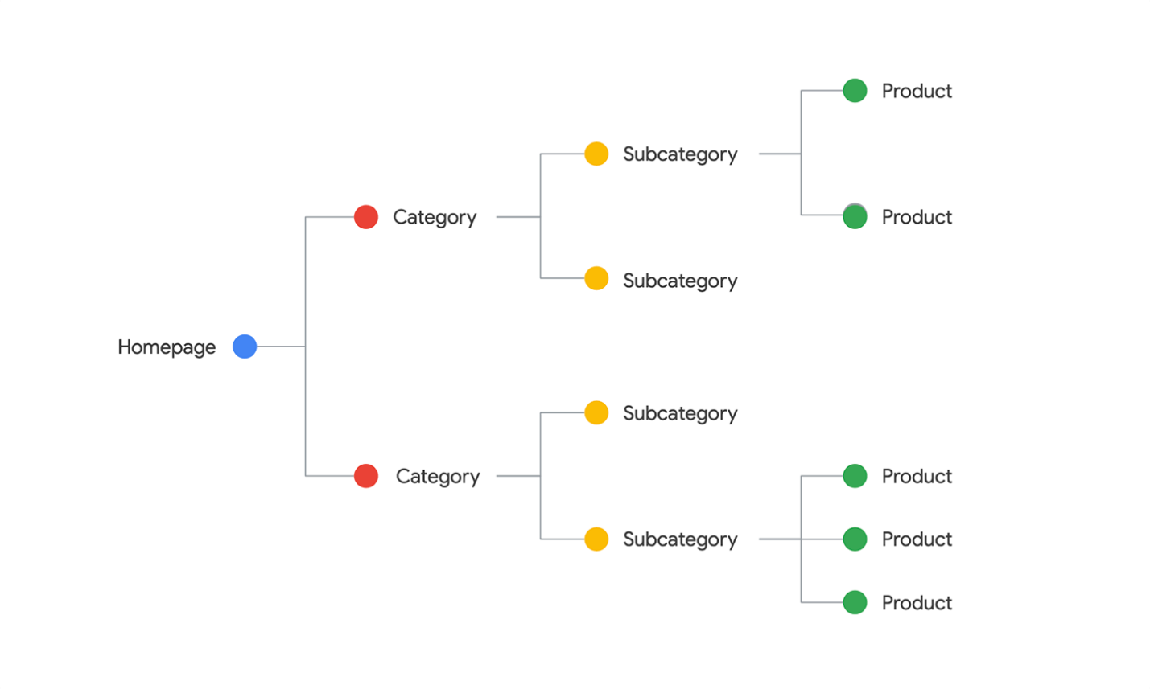

Imagine you work for an online bookstore. The homepage for the online bookstore would feature content that interests the majority of their customers, such as current deals, new releases, and bestsellers.

The first level of site hierarchy below the homepage would include category pages, which group similar content or products together. For example, the categories for an online bookstore might include fiction, nonfiction, and children’s books.

The second level of site hierarchy would include subcategory pages, which are pages that relate to the category pages. For example, underneath the category page for children’s books, the website might include subcategories for chapter books, picture books, graphic novels, boxed sets, and other related subjects.

The third level of site hierarchy would include more specific information, such as a product detail page for a specific children’s book title.

The site hierarchy below demonstrates how a portion of the online bookstore’s website might be organized.

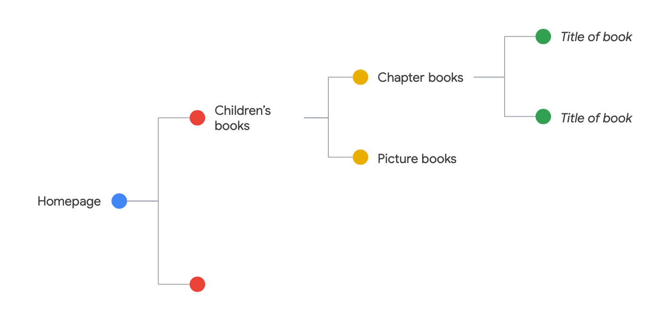

**Using breadcrumbs**

Let’s say a visitor finds their way to the product detail page for a specific children’s book*,* but then they want to browse other books. How do they return to a broader selection of books? One option would be to use **breadcrumbs,** which is a row of internal links at the top or bottom of the page that allows visitors to quickly navigate back to a previous section or the homepage.

Breadcrumbs typically begin with the homepage and include links for each level in the site hierarchy leading up to the page the visitor is currently on.

For example, the online bookstore’s breadcrumbs would start with the homepage, then include a link to the category page, and end with a link to the subcategory page. The breadcrumbs below demonstrate how this would be laid out:

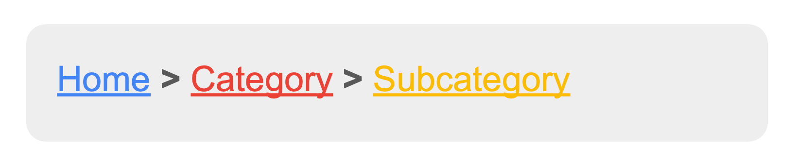

A visitor who lands on the product detail page for a specific book title would encounter a breadcrumb trail similar to this:

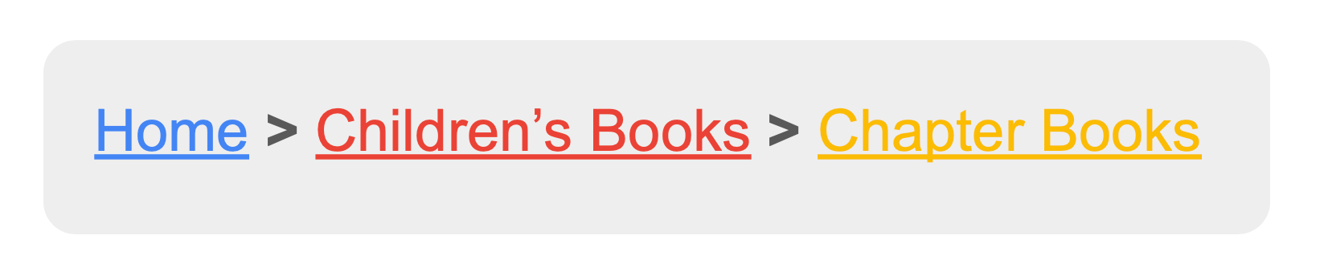

By clicking on one of these breadcrumb links, the visitor will be able to return to a broader selection of books.

**Using simple, descriptive URLs**

Another best practice for site hierarchy is to create URLs that are simple and descriptive. The text in the URLs should describe the content on the page. This makes it easy for visitors to understand what they’ll find when they visit that page. This also enhances SEO by making it easier for search engines to understand what the page is about.

**Best practices for URLs**

**Keep URLs as short as possible.**

* URLs that are too long can overwhelm or confuse your visitors.
* Shorter URLs make it easier for visitors to share a link to your page.

**Make URLs easy to understand.**

* Visitors should be able to tell where a link will take them when they click on the URL.
  + For example, if you’re creating a URL for a subcategory page for mystery books, you might use a URL like this: https://www.booksgalore.com/fiction/mystery. The visitor will know they are visiting a website about books. They’ll also know that the link will take them to mystery books within the fiction category. *Note*: the Books Galore is fictional and the link does not work.
* URLs should include words instead of cryptic numbers that don’t mean anything to the visitor. You’ll also want to avoid using generic words like “page1” or excessive keywords like “books-fiction-books-fictionbooks” in your URL.
* Keep in mind that URLs are visible in search engine results, which is why it’s important to make sure your URLs are user-friendly.

**Keep URLs updated.**

* A broken link may occur if a webpage is deleted, or if the content is moved to a different location. **Broken links** are links that lead to webpages that no longer exist.

**Create useful 404 pages.**

* Occasionally visitors may land on a **404 page**, which is a page that informs the user that the webpage they were trying to visit does not exist.
* 404 pages with a vague message or no guidance on what to do next will lead the visitor to a dead end.
* Custom 404 pages help guide the visitor back to a working page on your site.